UNIVERSITY OF SKILLS TRAINING AND ENTREPRENEURIAL DEVELOPMENT
FACULTY OF APPLIED SCIENCES AND MATHEMATICS EDUCATION
DEPARTMENT OF INFORMATION TECHNOLOGY EDUCATION
DESIGN AND DEVELOPMENT OF A SMART INFORMATION DISSEMINATION SYSTEM FOR ENHANCED STUDENT COMMUNICATION IN HIGHER EDUCATION
BY
BADU ADWOA NTIRIWAA - 5221040008
APPIAH JUSTICE BARFO - 5221040041
ASARE EDMUND BEDIAKO - 5221040297
THEOPHILUS KING ASARE - 5221040017
KYEI GYAMFI SOLOMON - 5221040042
JULY, 2026
CHAPTER THREE
METHODOLOGY

CHAPTER THREE
METHODOLOGY

3.1 Chapter Introduction
This chapter explains the methodology used to investigate the communication problem, define the requirements, design the Smart Information Dissemination System, implement the prototype, and plan its evaluation. It presents the research design, research setting, requirements-collection instruments, ethical considerations, proposed system, tools, development process, and the planning, analysis, design, and implementation phases of the System Development Life Cycle.
The chapter also incorporates the supplied high-level system architecture, system flowchart, and Entity-Relationship Diagram. The overview figures are followed by enlarged sections so that the components, processes, entities, and relationships remain readable in the project report.

3.2 Research Design/Approach
The project adopts a design-and-development research approach supported by a case-study strategy. The case study focuses on communication within a higher-education institution, while the design-and-development component produces and evaluates a software artefact. This approach is suitable because the project must understand existing institutional communication practices and transform the findings into a working system.
Requirements will be gathered qualitatively through observation, structured discussions or semi-structured interviews, document analysis, and review of related systems. Quantitative evidence will be obtained from system-generated test records and user-acceptance ratings. The mixed evidence will help the project evaluate both technical correctness and user experience.
Development will follow an Agile iterative process within the broader SDLC. Work will be divided into manageable increments for authentication, academic structures, user roles, announcements, audience targeting, notifications, messaging, schedules, reporting, audit logging, and external integrations. Each iteration will include design, implementation, testing, review, and refinement.

3.3 Research Setting
The research setting is a higher-education institution and its academic and administrative communication environment. Relevant units include central administration, faculties, departments, programme offices, admissions, academic affairs, information technology support, lecturers, students, and applicants. Communication occurs through physical notice boards, email, institutional portals, social-media groups, messaging applications, telephone calls, and verbal announcements.
The technical environment includes computers and mobile devices, web browsers, internet connectivity, a web application, a relational database, file storage, email and SMS providers, and an optional Student Information System. The prototype will use fictional or anonymized institutional and user data during development and testing. The final institution name and any site-specific characteristics should be inserted after formal approval.

3.4 Data (Requirements) Collection Instrument
Instrument | Source/Target | Purpose | Expected Output
Observation | Communication activities and channels | Identify publication steps, repeated work, delays, missed information, and informal workarounds. | Workflow notes and process requirements.
Semi-structured interviews or discussions | Administrators, department staff, lecturers, students, applicants, and IT personnel | Understand user roles, audience rules, notice categories, approval, schedules, preferences, privacy, and support needs. | User stories, business rules, and priorities.
Document analysis | Notice formats, academic calendars, schedules, admission notices, policies, email templates, and institutional structures | Identify data fields, categories, statuses, academic relationships, and report requirements. | Data dictionary and validation rules.
Existing-system review | LMS platforms, portals, email, messaging groups, and notification systems | Identify established features, limitations, and design patterns. | Comparative requirements and system gap.
Prototype walkthrough and questionnaire | Representative users | Assess usefulness, ease of use, clarity, task completion, satisfaction, and missing functions. | User-acceptance evidence and improvement requests.
System-generated records | Test environment | Measure response time, notification success, authorization, audit events, and functional accuracy. | Technical evaluation results.
Table 3.1: Requirements and evaluation instruments
The collected information will be coded into themes and converted into functional requirements, non-functional requirements, user stories, business rules, data entities, process flows, validation rules, and acceptance criteria. Conflicting requirements will be reviewed with the relevant stakeholders before implementation.

3.5 Ethical Considerations
Permission will be obtained from the supervisor and the participating institution before collecting information from staff, students, or applicants. Participation in interviews, discussions, walkthroughs, and questionnaires will be voluntary. Participants will be informed of the purpose of the project and how their information will be used.
The project will minimize personal data and use participant codes in research records. Demonstrations and screenshots will use fictional or masked names, email addresses, phone numbers, academic identifiers, and messages unless explicit permission is obtained. Confidential student records, admission decisions, and restricted notices will not be included in public repositories or appendices.
The system will enforce role-based access, protected sessions, secure password handling, input validation, controlled attachments, audit logs, and encrypted communication in production. Users will be informed that read tracking records access to a notice but does not measure understanding. Research and system data will be retained only for the approved period and protected according to institutional policy.

3.6 Description of Proposed System
The proposed system is a responsive, role-aware web application that centralizes institutional notices, messages, academic schedules, notifications, search, archives, read and delivery tracking, reporting, and administrative audit records. The system supports super administrators, institution administrators, department administrators, lecturers, students, and applicants.
User Role | Main Responsibilities
Super Administrator | Manage platform settings, institutions, global roles and permissions, integrations, system-wide reports, and audit monitoring.
Institution Administrator | Manage faculties, departments, programmes, academic periods, users, announcements, audience rules, schedules, notification settings, and reports.
Department Administrator | Manage departmental notices, programmes, class groups, departmental schedules, lecturer assignments, and communication reports within assigned scope.
Lecturer | Publish or submit course-related notices, communicate with assigned audiences, view schedules, manage messages, and review notification history.
Student | View targeted notices and schedules, receive notifications, search archives, manage preferences, participate in permitted messages, and track unread content.
Applicant | View admission and registration notices, applicant schedules, institutional guidance, and notifications relevant to the application process.
Table 3.2: System users and responsibilities

3.7 System Development/Building

3.7.1 Tools
Tool/Technology | Purpose | Justification
Next.js and React | Responsive presentation and full-stack application framework. | Support layouts, server and client components, routing, and API endpoints.
TypeScript | Programming language. | Improves maintainability through static typing and clearer contracts.
Tailwind CSS and reusable UI components | Interface styling. | Support responsive, consistent, and accessible screens.
TanStack React Query and Axios | Server-state retrieval and HTTP communication. | Support caching, loading states, retries, and request organization.
Zustand | Limited client-side state management. | Supports local interface state without unnecessary complexity.
React Hook Form and Zod | Forms and validation. | Support structured input handling and shared validation rules.
Next.js Route Handlers/Node.js services | Application APIs and business logic. | Provide protected endpoints for announcements, messages, schedules, notifications, and reports.
Prisma ORM | Typed data access and database migrations. | Supports relationships, constraints, transactions, and query validation.
PostgreSQL | Relational database. | Supports integrity, indexes, transactions, reporting, and scalable structured storage.
SMTP and SMS providers | External notification delivery. | Provide supporting channels for urgent or important notices.
Cloud file storage | Attachment and media storage. | Separates file delivery from the application database.
Postman, automated tests, and browser tools | API, functional, integration, and performance testing. | Provide repeatable evidence of system correctness.
Git and GitHub | Version control and collaboration. | Support code history, team development, issue tracking, and recovery.
Vercel or comparable hosting | Deployment and continuous delivery. | Supports secure web hosting and deployment automation.
Table 3.3: Proposed system development tools

3.7.2 Development Process
The project will use Agile iterations organised around a prioritized backlog. Early iterations will implement authentication, roles, institutions, faculties, departments, programmes, and users. Later iterations will add announcements, audiences, schedules, messaging, notifications, read and delivery tracking, search, reports, audit logs, external services, and final system hardening.
Each iteration will define acceptance criteria before coding. Completed functions will be tested and demonstrated, and feedback will be converted into corrections or new backlog items. Version control, code review, database migrations, and automated tests will be used to maintain consistency as the system grows.

3.8 The System Development Life Cycle (SDLC)

3.8.1 Planning Phase
The planning phase defined the communication problem, project aim, objectives, scope, stakeholders, resources, schedule, risks, and expected outputs. Key risks include incorrect audience targeting, disclosure of restricted information, notification-provider failure, low user adoption, poor data quality, duplicate delivery, and dependency on institutional identity data.
The team selected a modular web architecture and identified the core modules required for a demonstrable prototype. A project backlog and milestone plan will guide analysis, design, implementation, testing, documentation, deployment, and presentation.

3.8.2 Analysis Phase
During analysis, the team will document existing communication channels, user responsibilities, publication and approval practices, audience definitions, notification categories, schedule types, messages, reports, and security expectations. Requirements will be validated against the project objectives and prioritized according to importance and feasibility.
ID | Functional Requirement
FR-01 | Authenticate users, recover passwords, manage sessions, and enforce account status.
FR-02 | Assign roles and permissions and display role-specific portals.
FR-03 | Manage institutions, faculties, departments, programmes, courses, class groups, academic years, and semesters.
FR-04 | Create, edit, schedule, publish, archive, withdraw, and categorize announcements.
FR-05 | Target announcements to roles, institutions, faculties, departments, programmes, courses, class groups, academic periods, direct users, or combined audiences.
FR-06 | Upload and retrieve authorized attachments and media.
FR-07 | Create in-app notifications and optionally send email or SMS messages.
FR-08 | Allow users to manage permitted notification preferences.
FR-09 | Record notification delivery attempts, status, and errors.
FR-10 | Record announcement views, message reads, and unread counts.
FR-11 | Support direct and thread-based messaging among authorized participants.
FR-12 | Manage academic schedules and notify affected audiences of changes.
FR-13 | Search, filter, tag, and archive notices, messages, and schedules.
FR-14 | Generate dashboards and reports on publication, delivery, reads, unread content, and communication activity.
FR-15 | Record important authentication, administrative, content, and security events in an audit log.
FR-16 | Provide a controlled integration interface for importing or synchronizing institutional data.
Table 3.4: Functional requirements
Quality Attribute | Requirement
Security | Protected authentication, server-side authorization, secure sessions, validation, attachment controls, HTTPS, rate limiting, audit logs, and secret management.
Privacy | Purpose-specific data collection, least-privilege access, retention controls, and protected personal and academic information.
Performance | Common pages and requests should complete within acceptable times under representative load.
Reliability | Published content and confirmed notification records should not be lost or duplicated.
Availability | The platform should remain available except during planned maintenance or provider outages.
Usability | Role-specific dashboards, clear navigation, readable content, understandable status labels, and useful error feedback.
Accessibility | Keyboard operation, adequate contrast, meaningful labels, responsive design, and compatible error messages.
Maintainability | Typed modular code, documented APIs, migrations, tests, version control, and configuration separation.
Scalability | Support growth in users, institutions, audiences, announcements, messages, notifications, and audit records.
Data Integrity | Use constraints, transactions, unique identifiers, foreign keys, and validation to prevent inconsistent records.
Auditability | Record important actions with actor, time, affected record, and relevant metadata.
Table 3.5: Non-functional requirements

3.8.3 Design Phase
The design phase translates the approved requirements into the layered architecture, role-specific interfaces, application services, workflow rules, API contracts, database schema, security controls, and test cases. The supplied diagrams present the major users, application layers, processes, and relational entities.

3.8.3.1 High-Level System Architecture
The architecture contains a system-user layer, presentation layer, client-data and validation layer, API and security layer, application and business-services layer, data-access layer, PostgreSQL database layer, and external-services layer. The user layer includes the super administrator, institution administrator, department administrator, lecturer, student, and applicant. The presentation layer provides public and role-specific portals.
Application services include authentication, user and profile management, institutional structure, audience management, announcements, messaging, academic schedules, notifications, notification preferences, read and delivery tracking, search and archives, reporting and analytics, audit logging, and an external-service bus. Prisma ORM provides data access, while PostgreSQL stores authentication, institutional, communication, academic, notification, reporting, and security records.
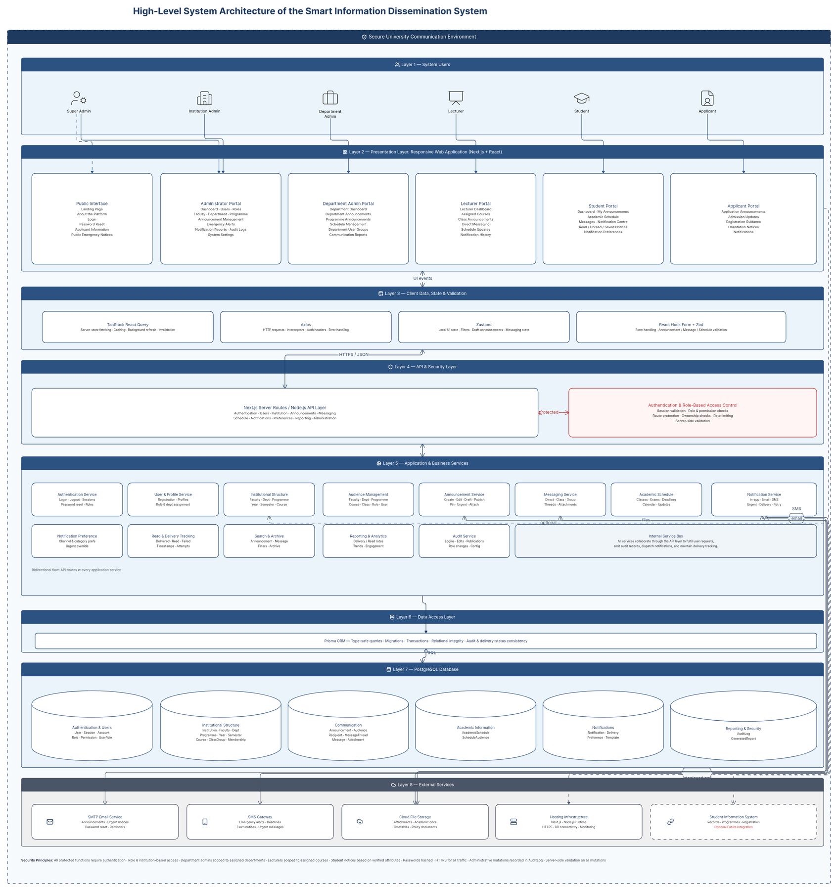
Figure 3.1: High-level system architecture of the Smart Information Dissemination System

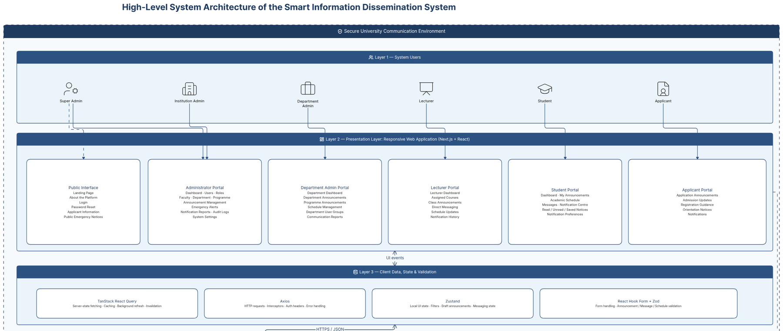
Figure 3.1a: Architecture detail - system users, presentation portals, and client-state services

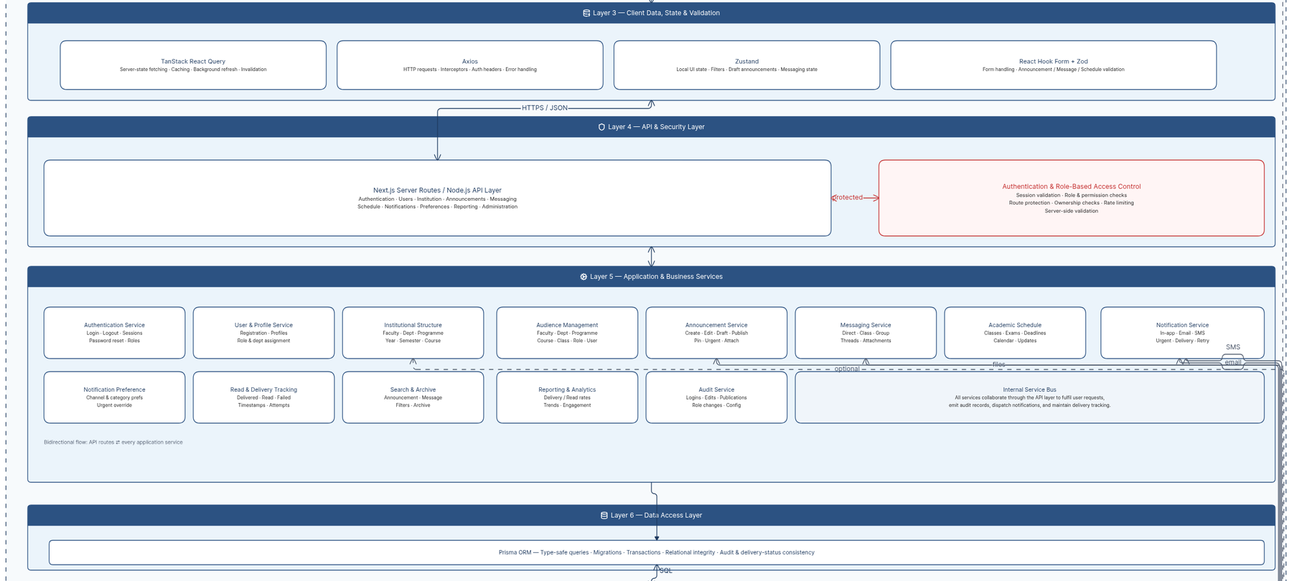
Figure 3.1b: Architecture detail - API security and application business services

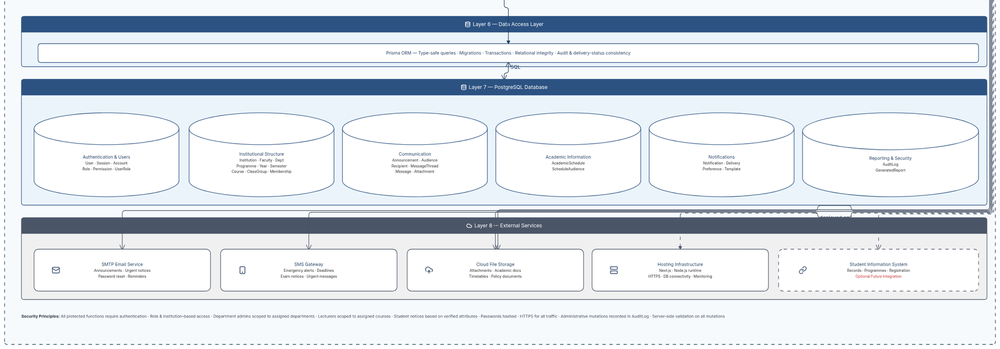
Figure 3.1c: Architecture detail - data access, database modules, and external services

3.8.3.2 System Flowchart
The system flowchart presents the main operational paths across authentication, role detection, institution and user management, announcement creation, audience selection, approval and publication, messaging, academic schedules, notification generation, external delivery, read tracking, reporting, and audit logging. Decision points reject invalid credentials, unauthorized actions, incomplete content, invalid audiences, and failed provider responses.

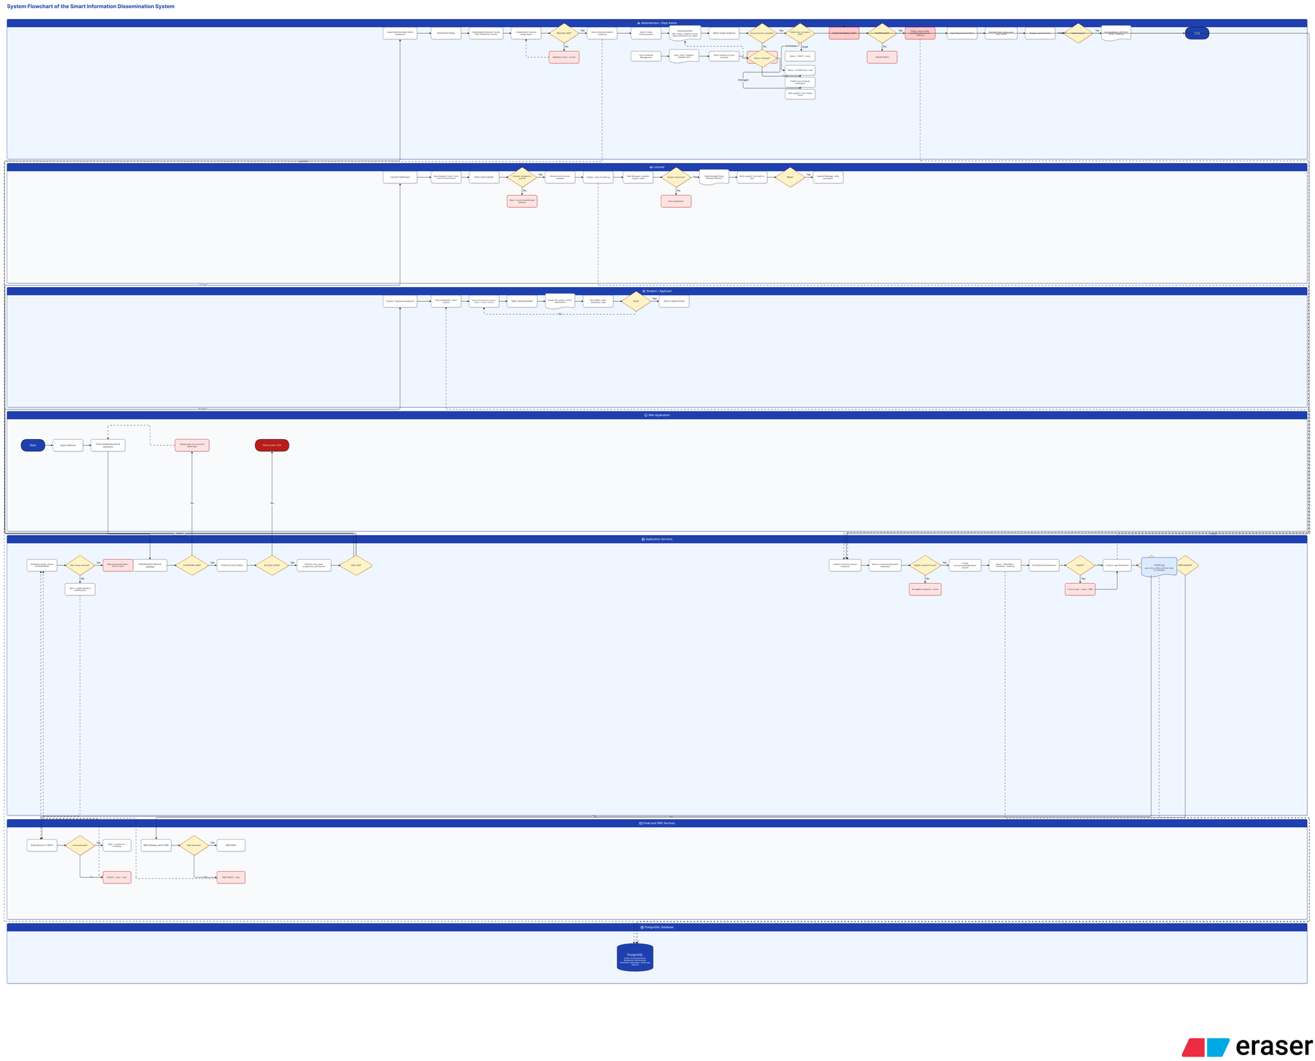
Figure 3.2: Overview of the Smart Information Dissemination System flowchart

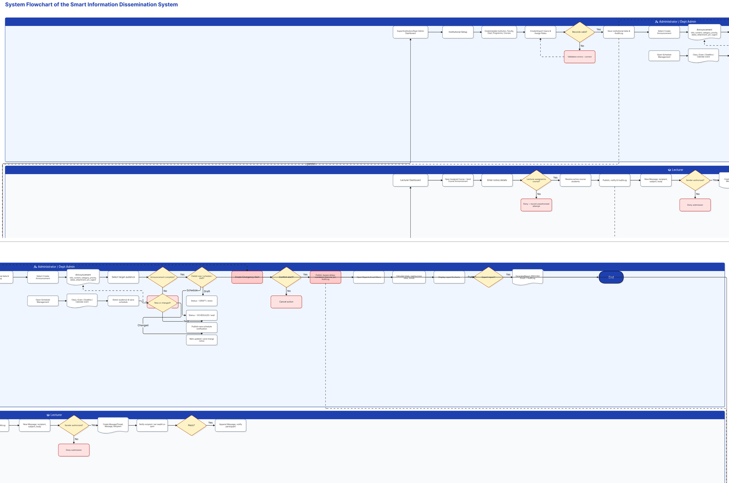
Figure 3.2a: Flowchart detail - authentication, role resolution, and administrative setup

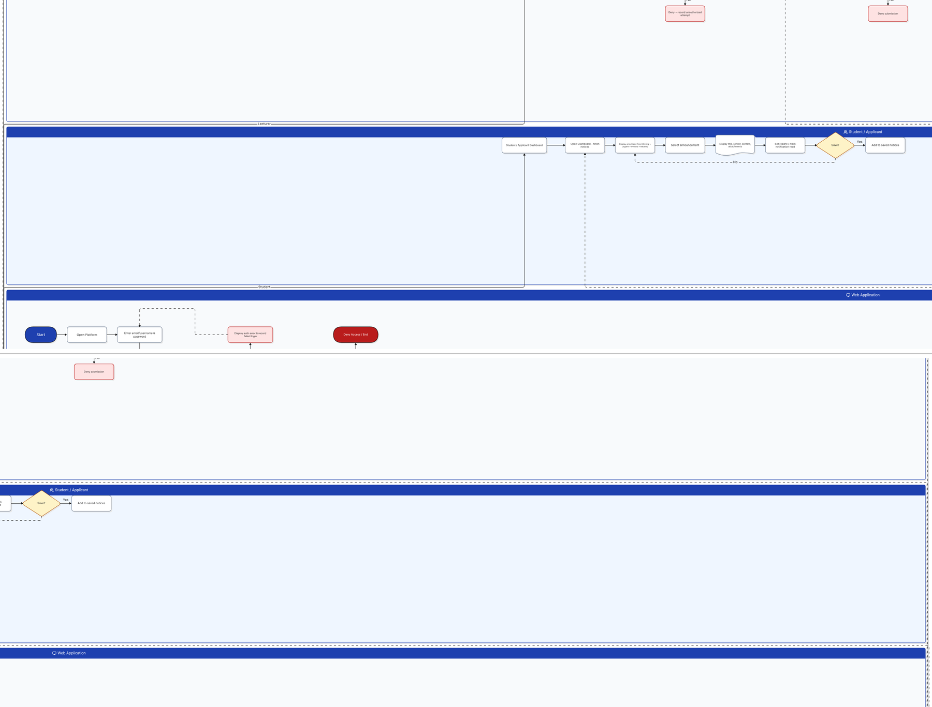
Figure 3.2b: Flowchart detail - announcement preparation, audience selection, approval, and publication

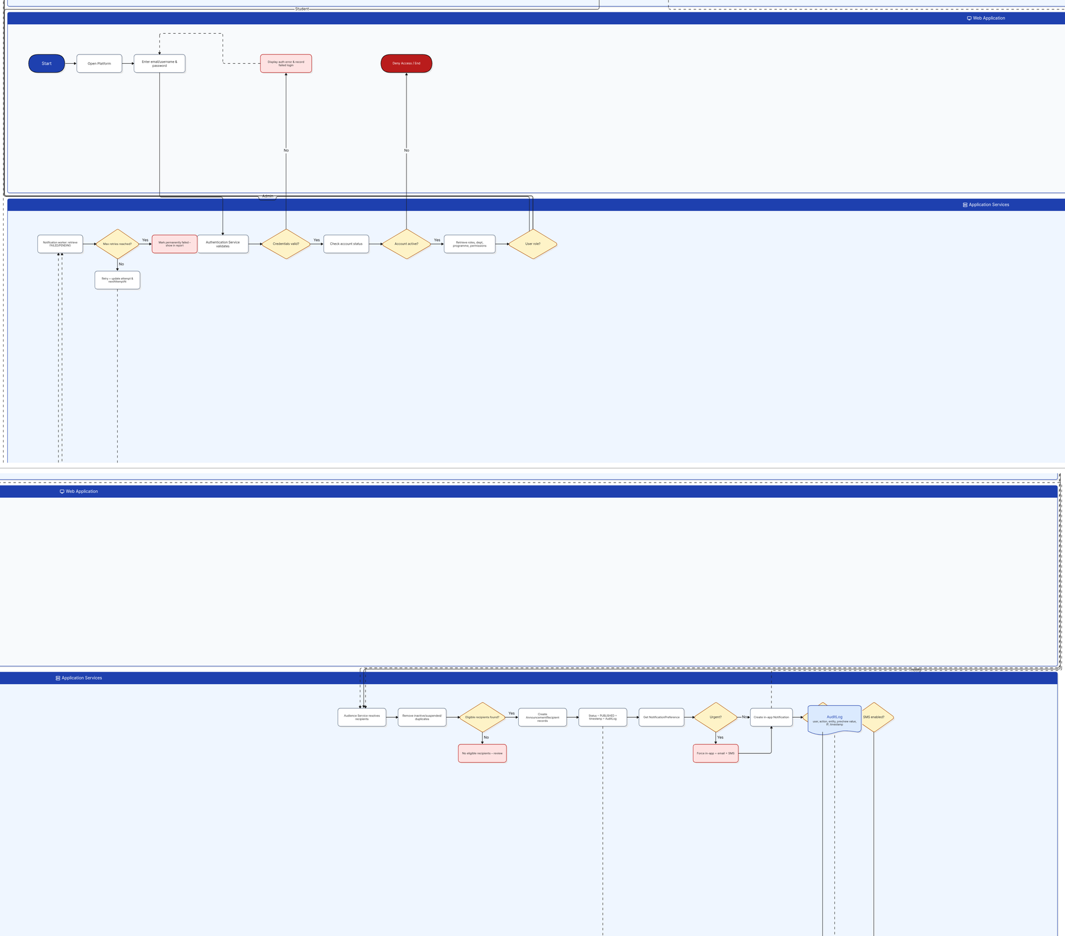
Figure 3.2c: Flowchart detail - messaging, academic schedules, and supporting communication processes

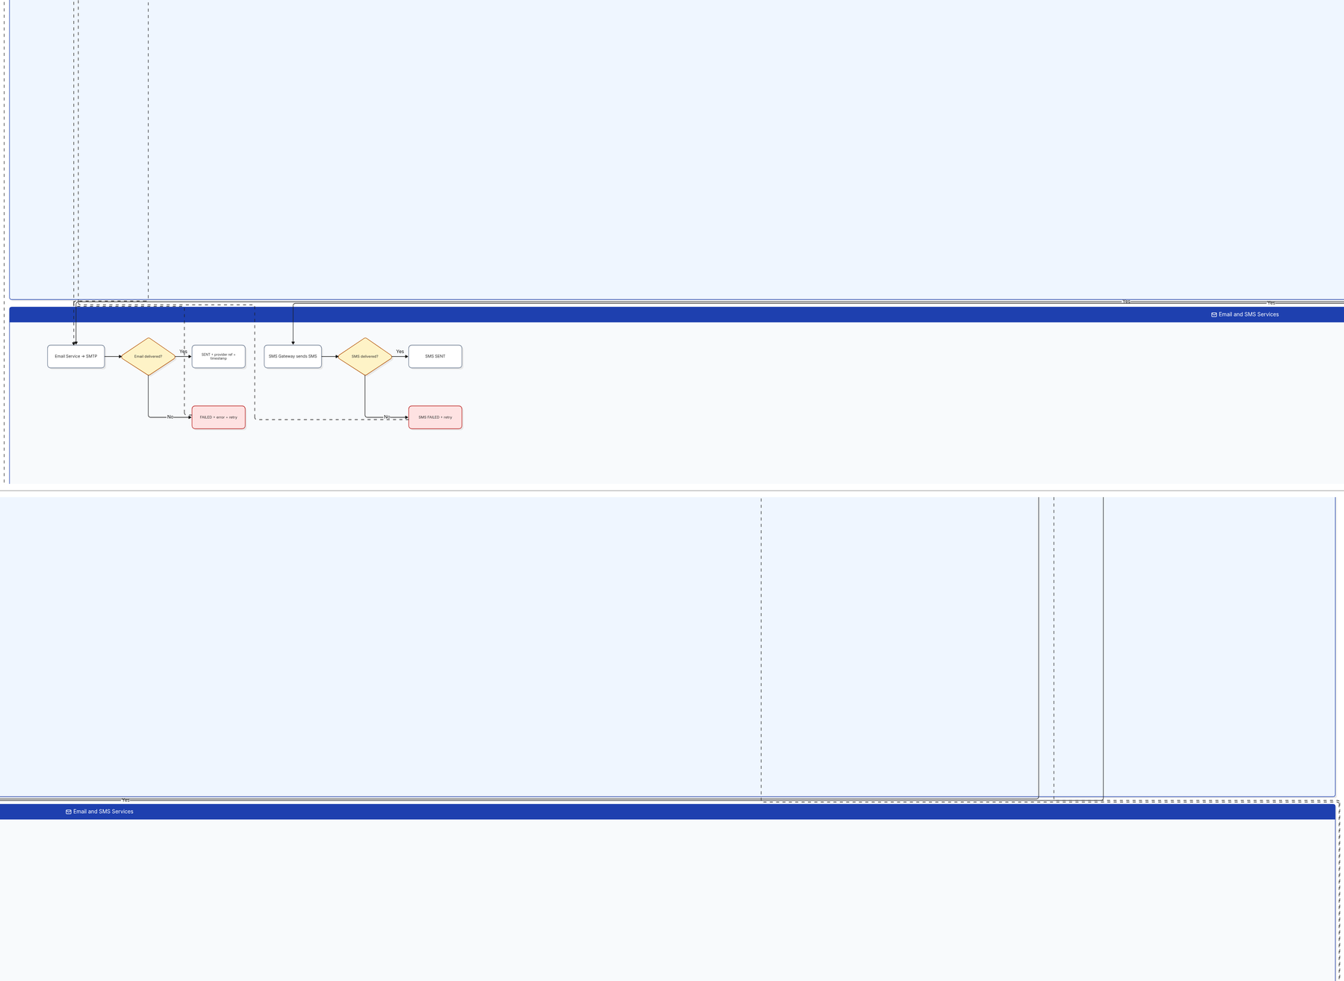
Figure 3.2d: Flowchart detail - notification creation, external delivery, and user interaction

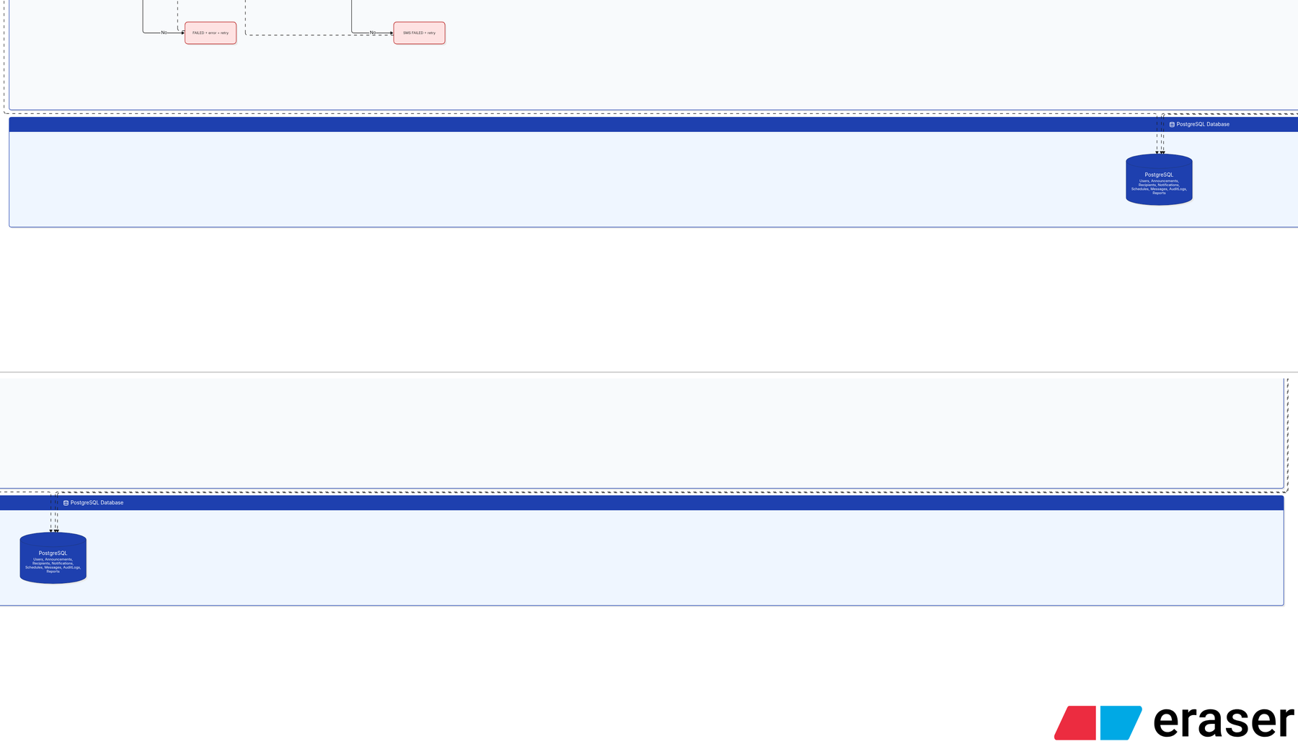
Figure 3.2e: Flowchart detail - read tracking, reporting, audit records, and data persistence

3.8.3.3 Entity-Relationship Diagram and Database Design
The Entity-Relationship Diagram defines the data required to preserve users, roles, permissions, institutional structures, announcements, audiences, recipients, attachments, messages, threads, schedules, notifications, delivery records, preferences, sessions, reports, and audit logs. Primary keys identify records, while foreign keys and join entities preserve many-to-many relationships such as users and roles, roles and permissions, announcements and audiences, threads and participants, students and courses, and notices and recipients.

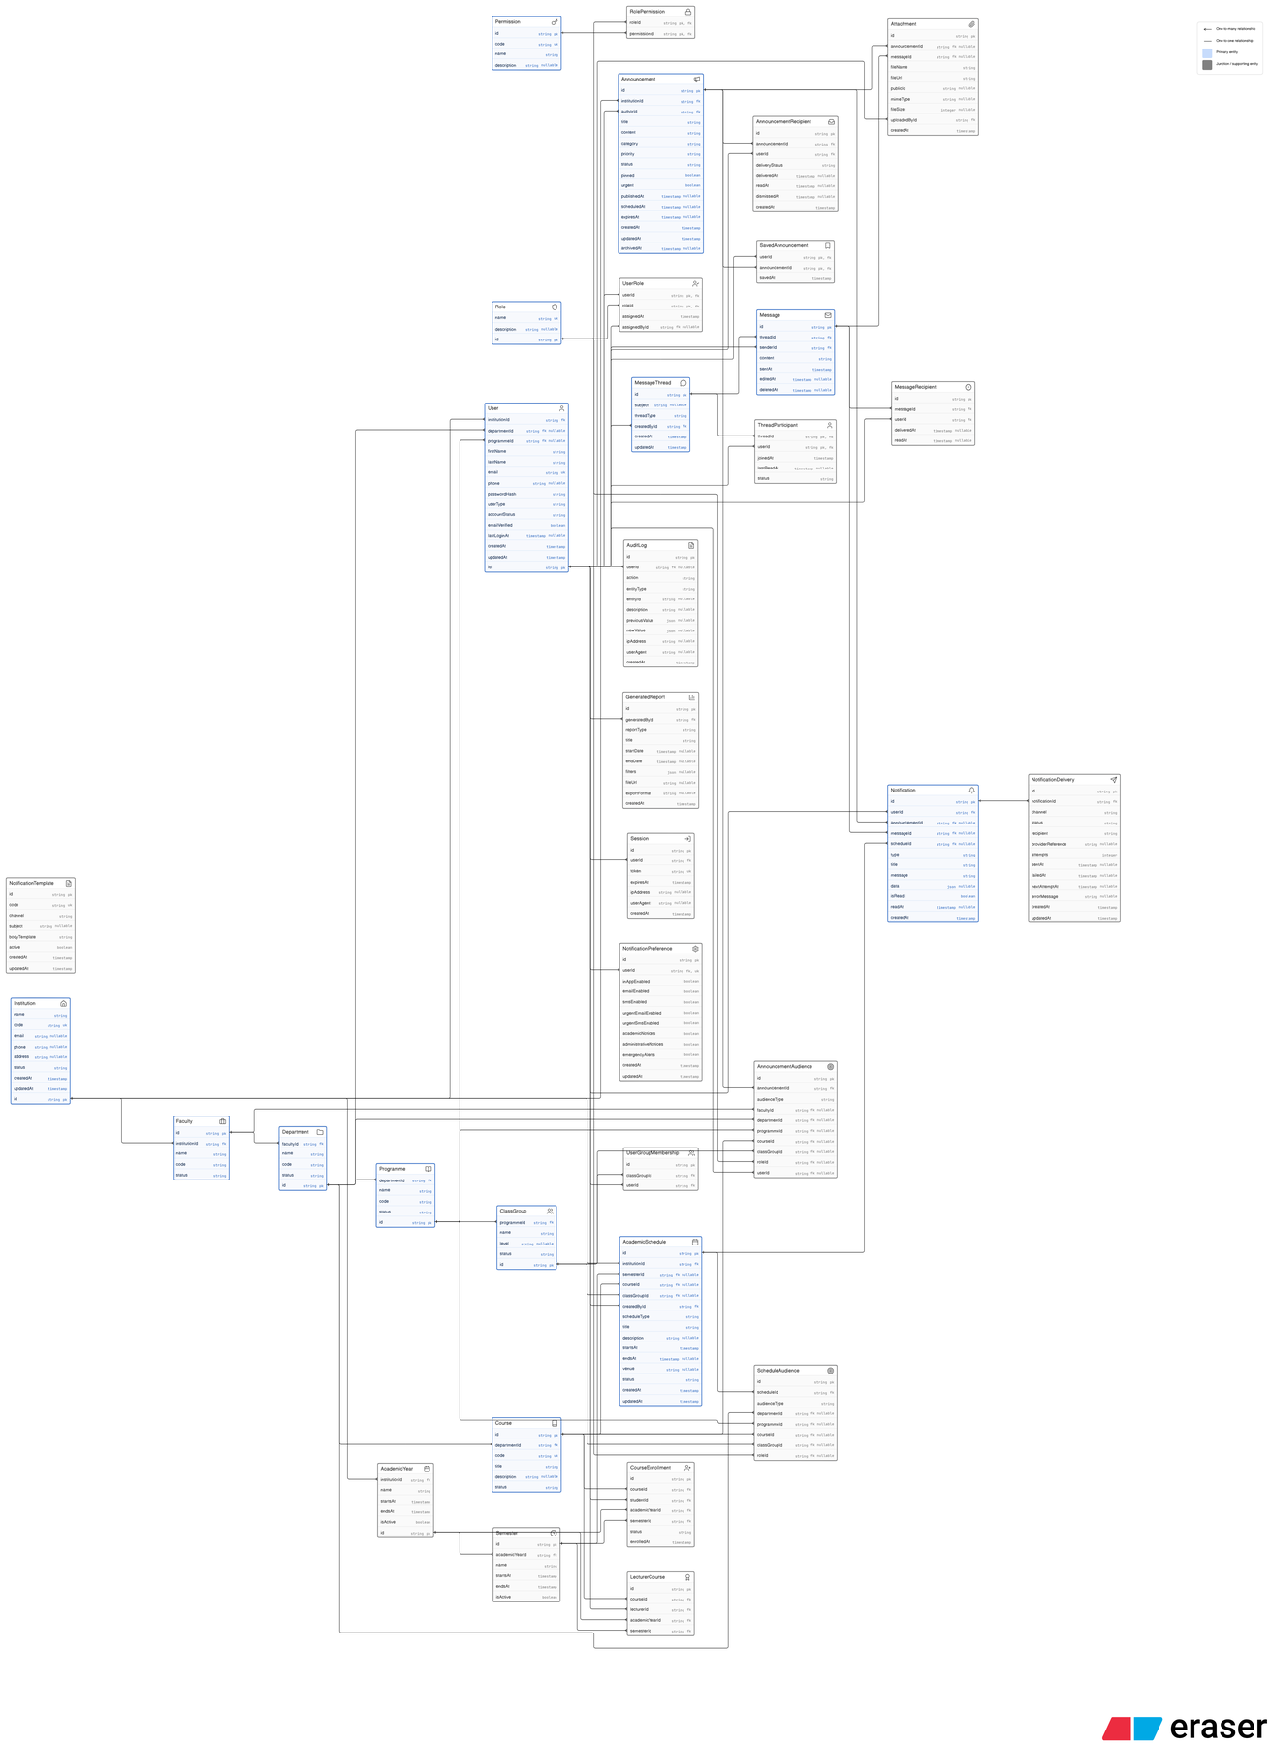
Figure 3.3: Entity-Relationship Diagram of the Smart Information Dissemination System

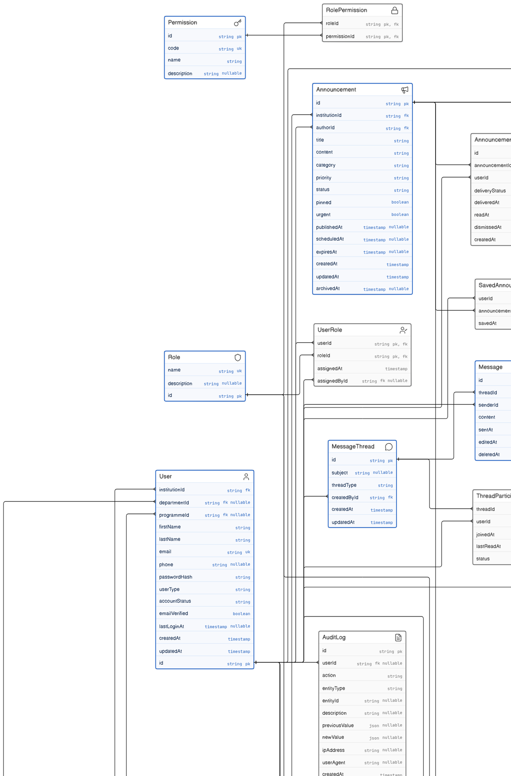
Figure 3.3a: ERD detail - permissions, authentication, user accounts, and core communication entities

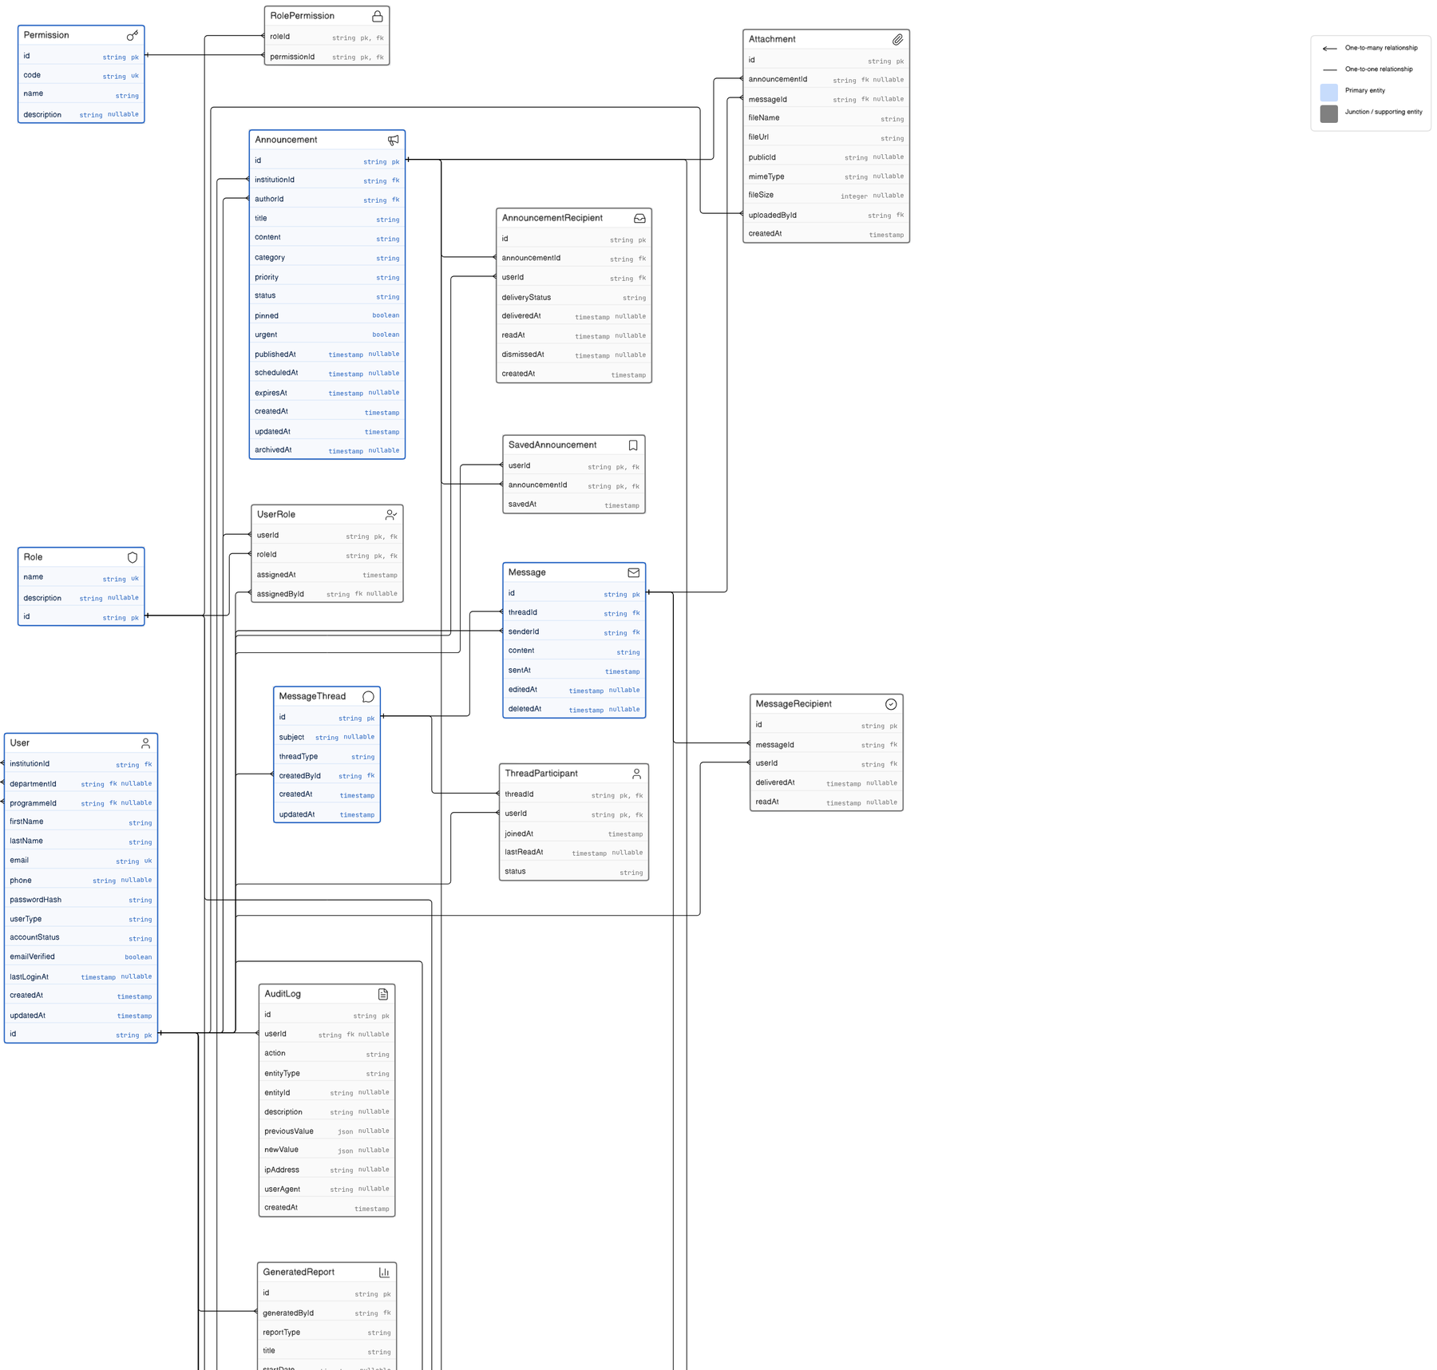
Figure 3.3b: ERD detail - announcements, recipients, attachments, messages, and message participants

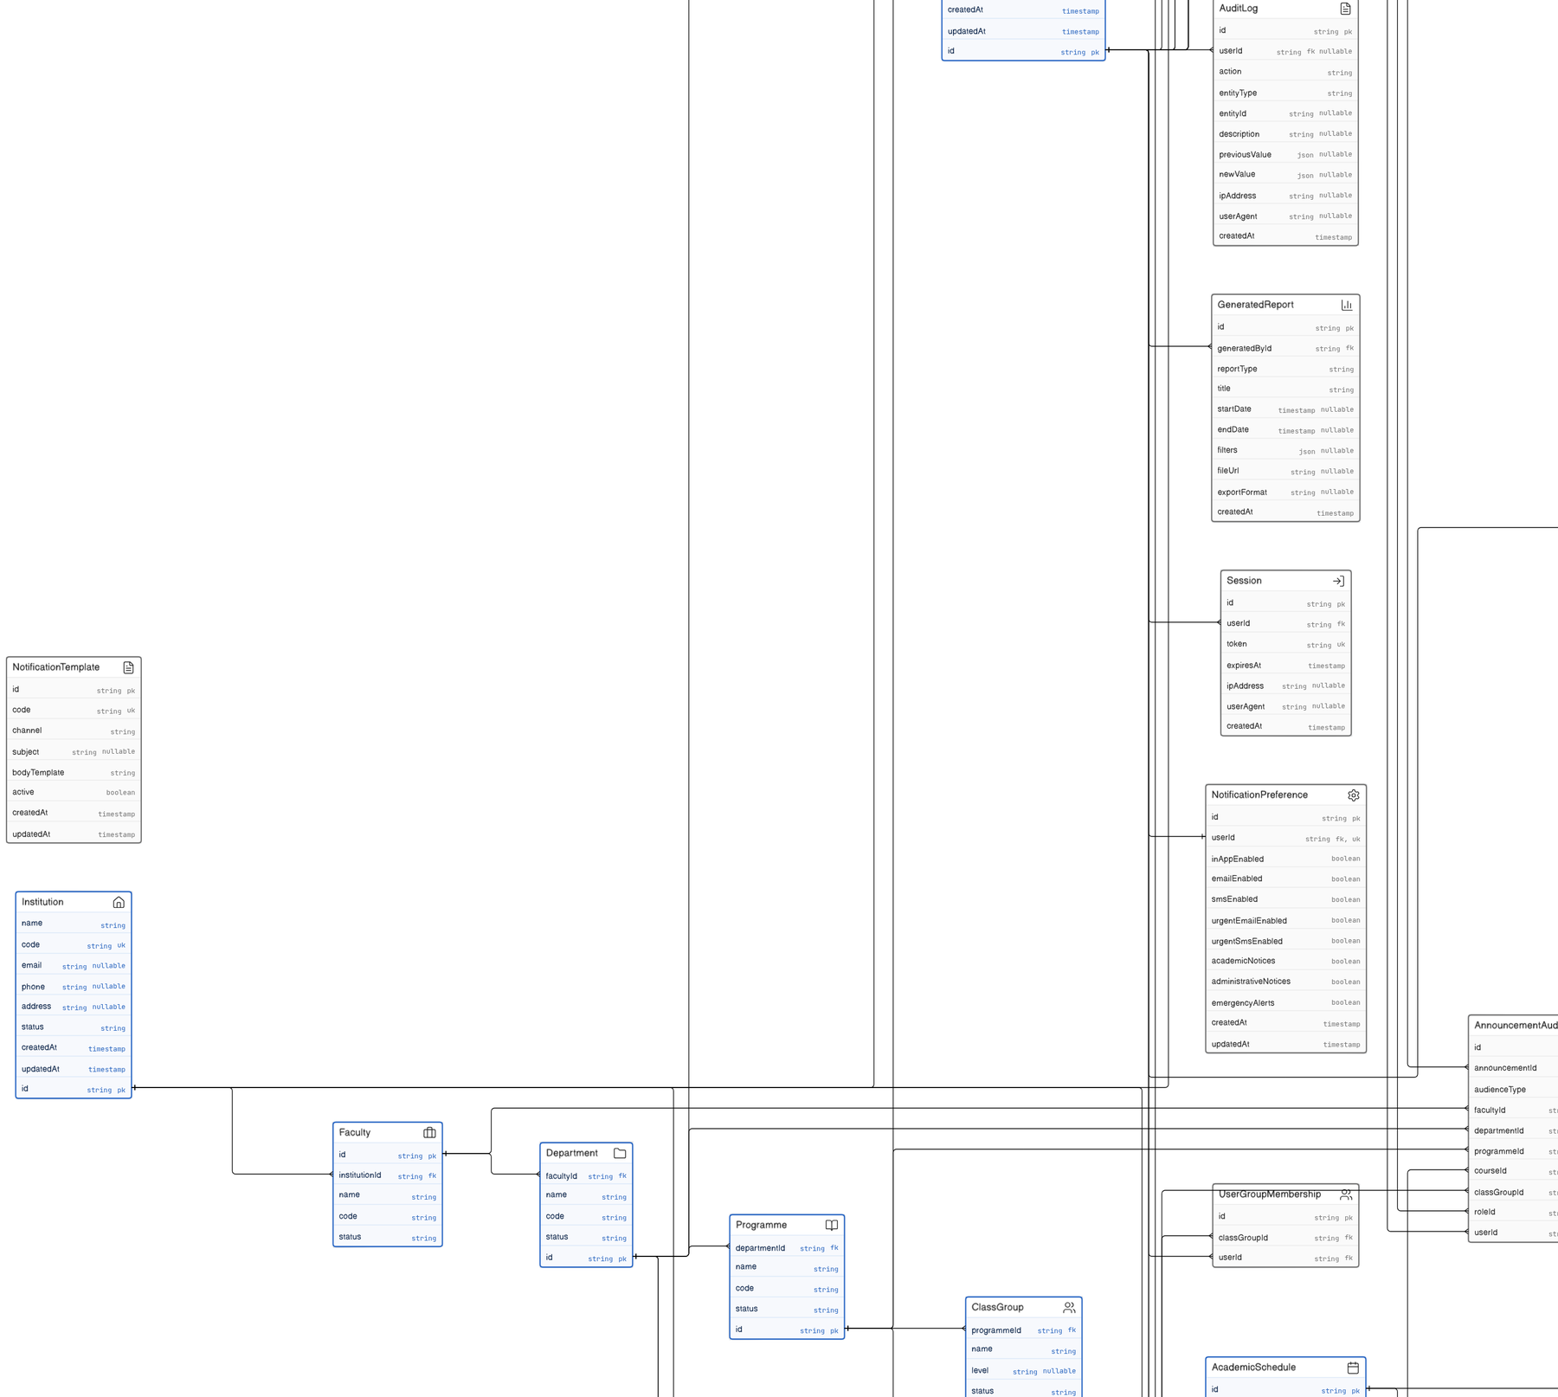
Figure 3.3c: ERD detail - sessions, notification preferences, audit logs, and delivery-related entities

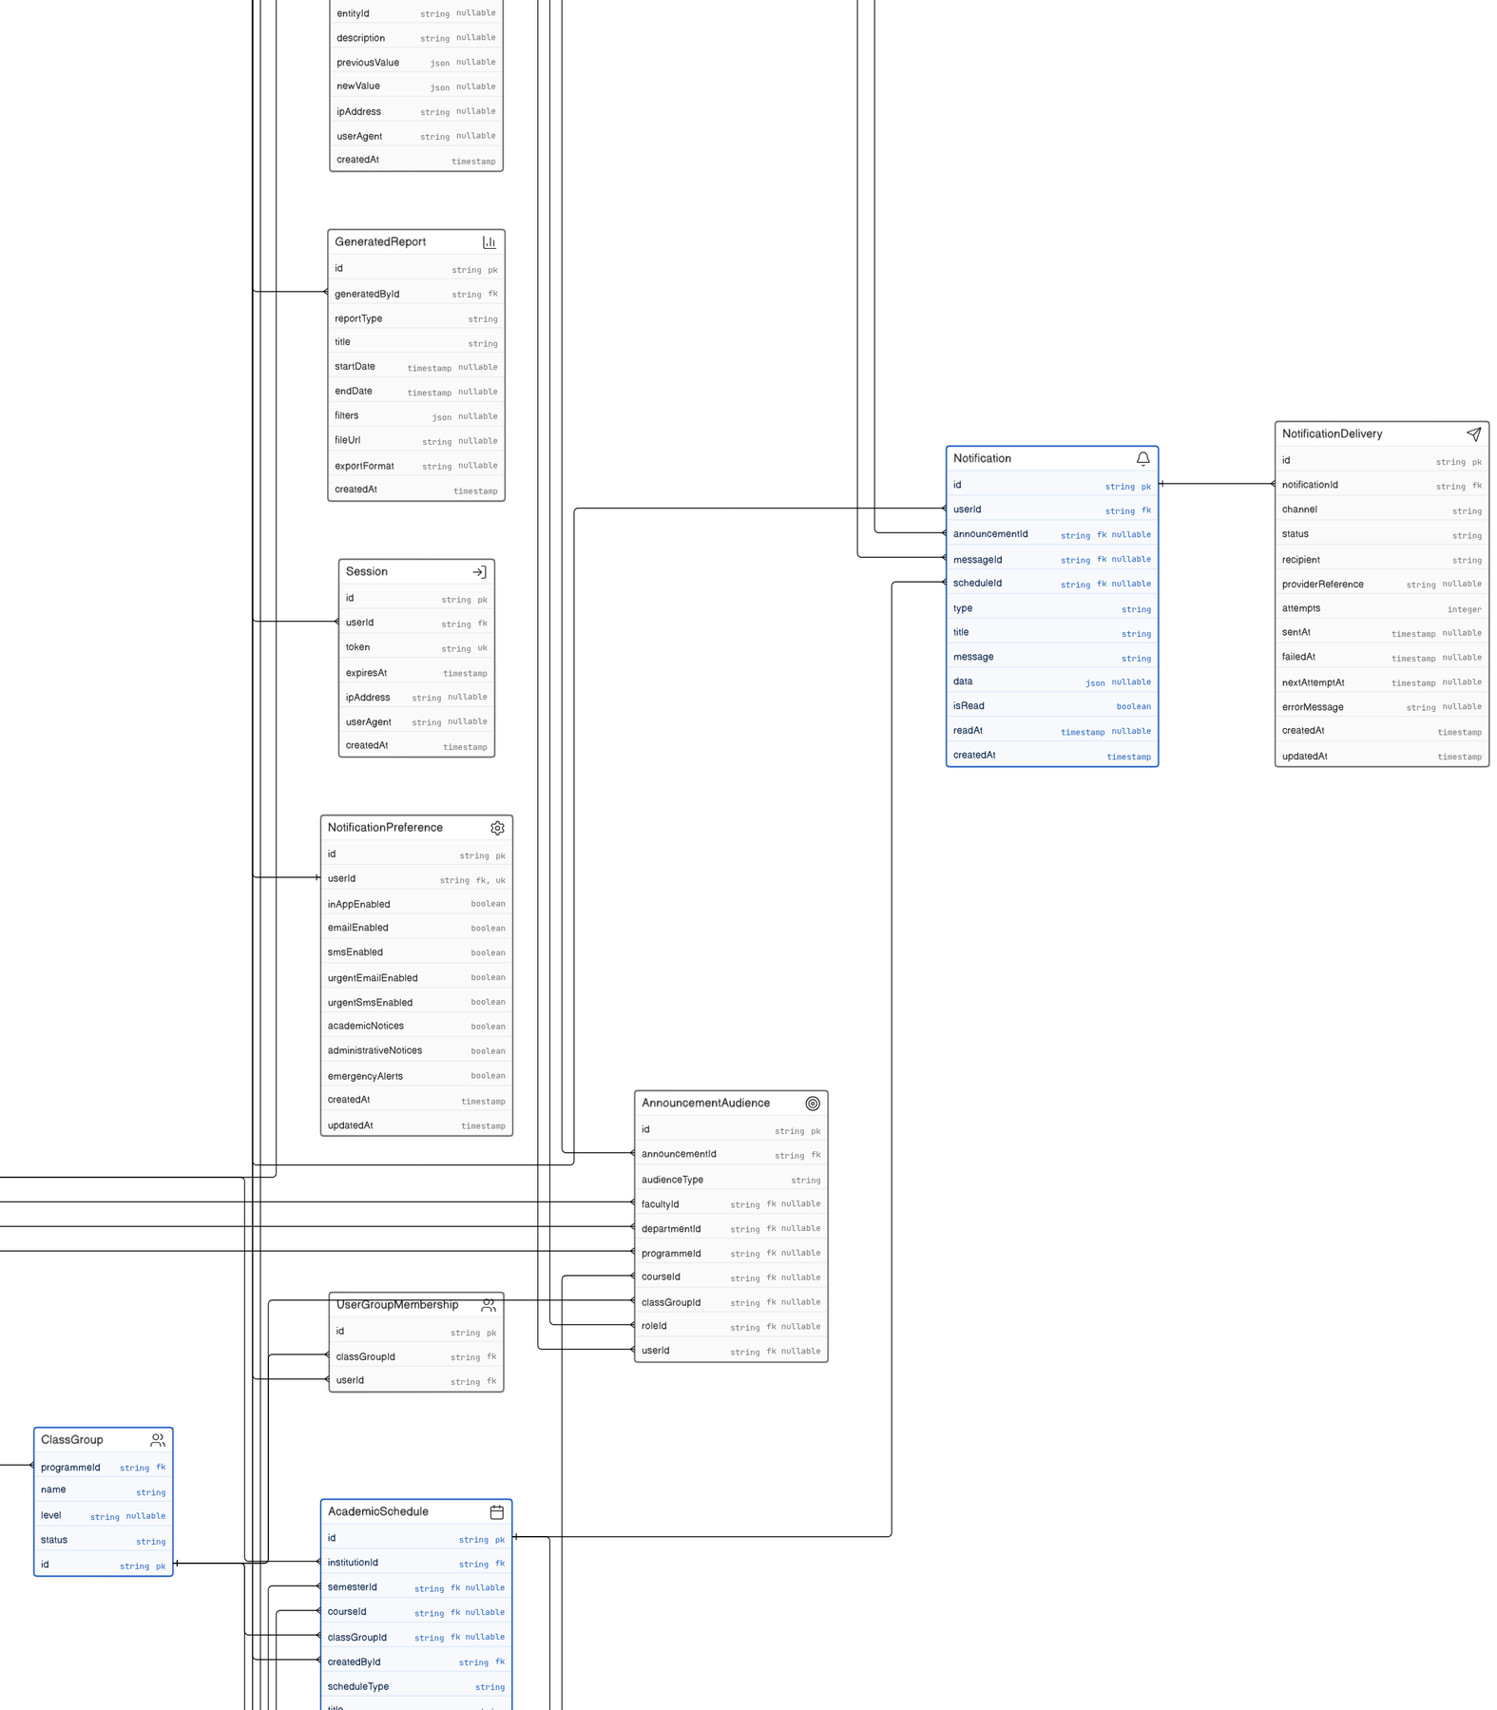
Figure 3.3d: ERD detail - notifications, academic audiences, and announcement-audience relationships

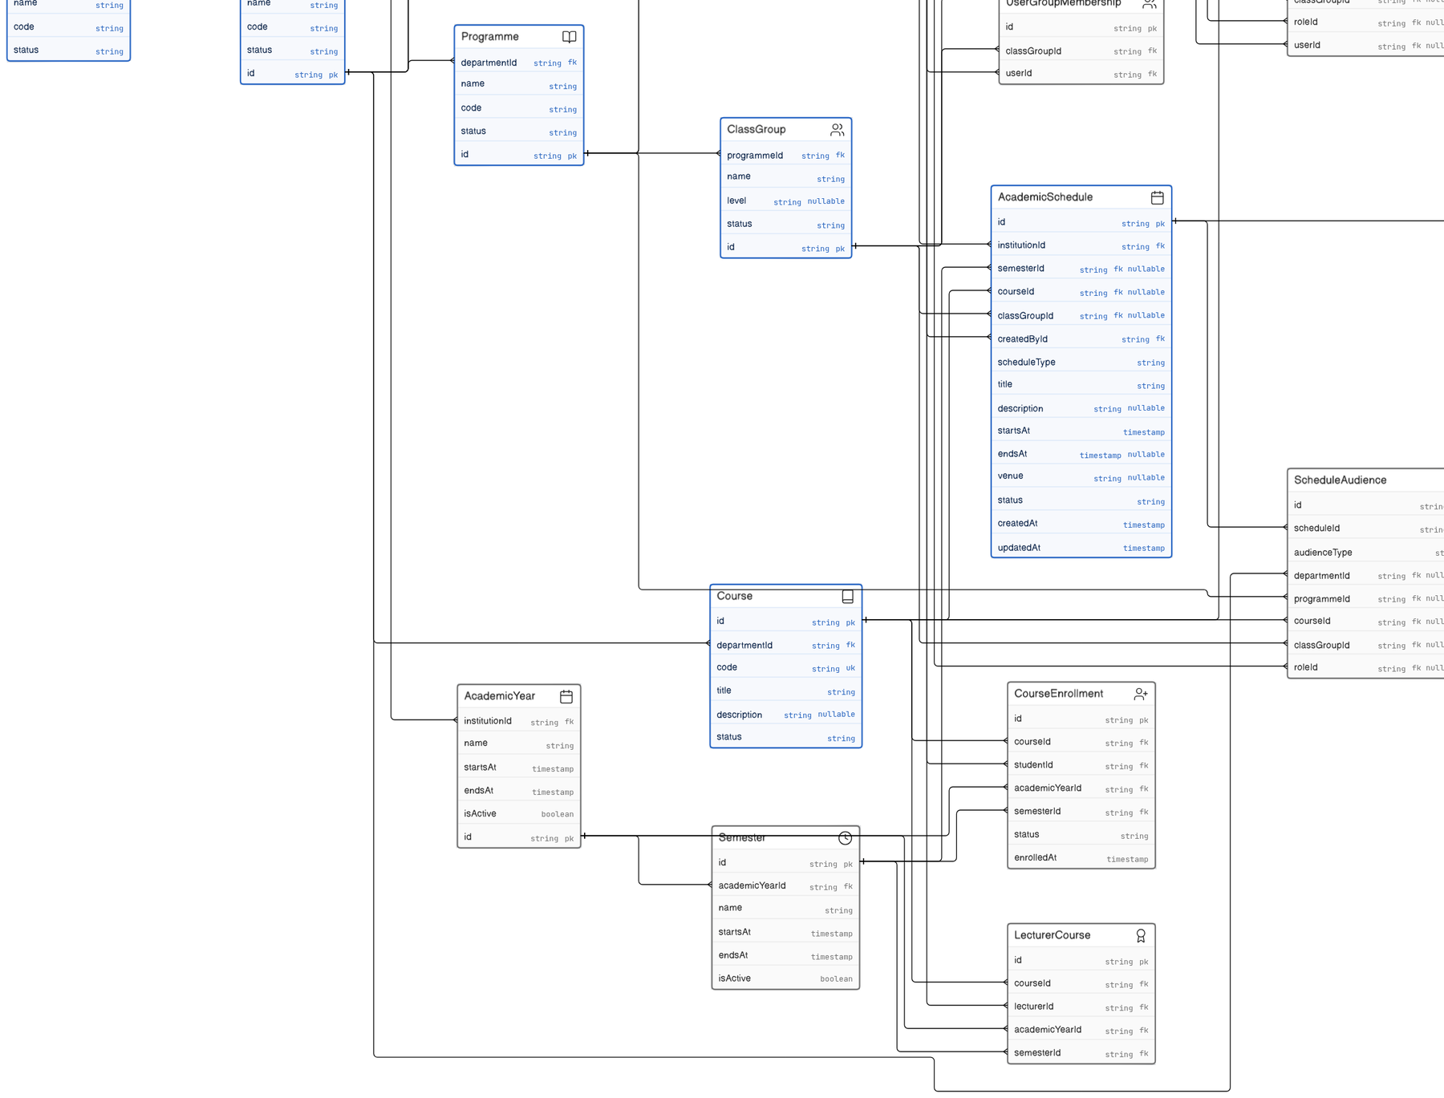
Figure 3.3e: ERD detail - institution, faculty, department, programme, course, and academic period entities

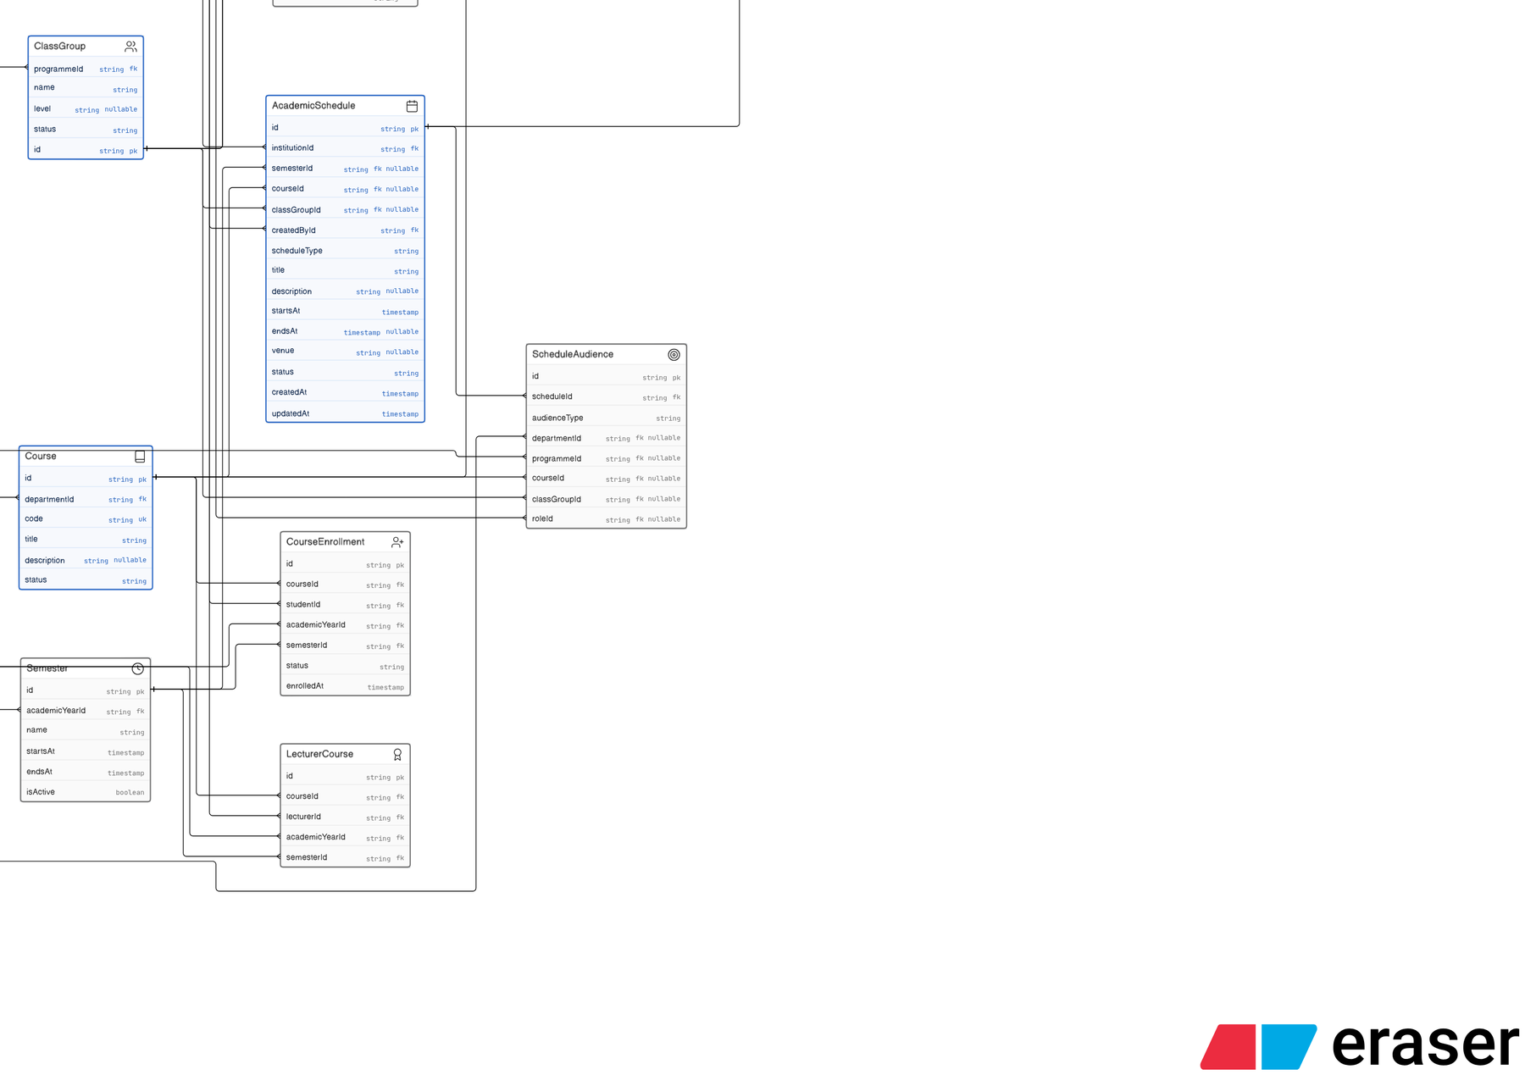
Figure 3.3f: ERD detail - course enrolment, lecturer assignments, student audiences, and academic schedules

Entity Group | Purpose
User, Session, Role, Permission, UserRole, RolePermission | Identity, authentication, account status, sessions, and authorization.
Institution, Faculty, Department, Programme, Course, ClassGroup | Institutional and academic hierarchy used for audience targeting.
AcademicYear, Semester, AcademicSchedule | Academic periods, schedules, deadlines, and time-bound events.
Announcement, AnnouncementRecipient, SavedAnnouncement, Attachment | Official notices, delivery recipients, saved content, and attached files.
AnnouncementAudience and academic audience entities | Audience rules that connect notices to institutional and academic groups.
MessageThread, ThreadParticipant, Message, MessageParticipant | Direct and threaded communication, membership, and read state.
Notification, NotificationDelivery, NotificationPreference, NotificationTemplate | In-app and external delivery, user preferences, and message templates.
AuditLog and generated reports | Traceability, reporting, and administrative accountability.
Table 3.6: Major database entity groups

3.8.4 Implementation Phase
Implementation will begin with project configuration, the Prisma schema, PostgreSQL migrations, authentication, sessions, roles, permissions, and institutional structures. The announcement, audience, attachment, schedule, messaging, notification, preference, delivery, reporting, and audit modules will then be developed in prioritized iterations.
Server routes will validate requests and enforce authorization before accessing data. Transactions will protect multi-record operations such as publishing an announcement and creating recipients or notifications. Background or queued processes may be used for email and SMS delivery so that external-provider delays do not block the user interface. Automated tests will verify audience resolution, permissions, notification generation, read tracking, schedule updates, and report calculations.

3.9 Testing, Deployment, and Maintenance Plan
Test Type | Purpose
Unit testing | Validate audience rules, permission checks, validators, unread calculations, notification preference logic, and report calculations.
API testing | Verify request validation, authentication, authorization, status codes, and database changes.
Integration testing | Test interactions among announcements, audiences, notifications, email/SMS delivery, messaging, schedules, and audit logs.
Database testing | Verify constraints, relationships, migrations, indexes, transactions, and tenant/institution scope.
Security testing | Test invalid sessions, direct URL access, role escalation, malicious inputs, attachment restrictions, and audit coverage.
Performance testing | Measure common page, search, publication, and notification operations under representative load.
Accessibility testing | Check keyboard navigation, labels, contrast, focus, errors, and responsive layouts.
User-acceptance testing | Allow representative users to complete role-specific tasks and rate usefulness, ease of use, and satisfaction.
Table 3.7: Testing strategy
The application will be deployed through a controlled source-control and continuous-deployment workflow. Environment variables will separate development, test, and production credentials. Production migrations, HTTPS, the application domain, SMTP, SMS, cloud storage, backups, logging, and monitoring will be configured before user acceptance. Maintenance will include dependency updates, security patches, backup verification, delivery-provider monitoring, correction of defects, and periodic review of roles and notification policies.

3.10 Chapter Summary
This chapter presented the methodology for the Smart Information Dissemination System. It described the design-and-development approach, research setting, requirements instruments, ethical considerations, proposed system, tools, Agile process, SDLC phases, functional and non-functional requirements, architecture, flowchart, ERD, testing strategy, deployment, and maintenance. The next chapter demonstrates and evaluates the implemented prototype.

REFERENCES
Fielding, R. T., & Taylor, R. N. (2000). Architectural styles and the design of network-based software architectures. University of California, Irvine.
Next.js. (2026). Next.js documentation.
OWASP Foundation. (n.d.). OWASP Application Security Verification Standard.
PostgreSQL Global Development Group. (2026). PostgreSQL documentation.
Prisma Data, Inc. (2026). Prisma ORM documentation.
Schwaber, K., & Sutherland, J. (2020). The Scrum Guide.
Sommerville, I. (2016). Software engineering (10th ed.). Pearson.
World Wide Web Consortium. (2024). Web Content Accessibility Guidelines (WCAG) 2.2.

